PA Model Solution June 14, 2019

Exam PA June 2019 Project Report Template

**Instructions to Candidates: Please remember to avoid using your own name within this document or when naming your file. There is no limit on page count.**

As indicated in the instructions, work on each task should be presented in the designated section for that task.

# Task 1 – Explore the relationship of each variable to *Crash_Score* (5 points)

For the target variable Crash Score, the median is 7.16, the mean is 9.11, and the maximum is 83.41. This indicates that the distribution is skewed to the right. A histogram confirms this:

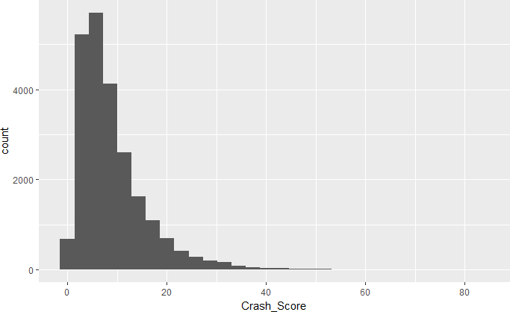

As a result, I explored boxplots of the log of the target variable split among the factors of each variable. Differences were observed for the following variables:

* Time_of_Day: Low Crash Score for period 1 (midnight to 4am)
* Rd_Feature: High for INTERSECTION and RAMP
* Rd_Character: High for OTHER
* Rd_Configuration: High for TWO‐WAY‐UNDPROTECTED‐MEDIAN
* Rd_Surface: Low for OTHER
* Rd_Conditions: High for WET, low for OTHER
* Light: Low for DARK‐NOT‐LIT and OTHER
* Weather: Low for OTHER
* Traffic_Control: Low for NONE and OTHER
* Work_Area: Low for NO.

The plot for Traffic_Control is provided below. The others can be obtained from the R code.

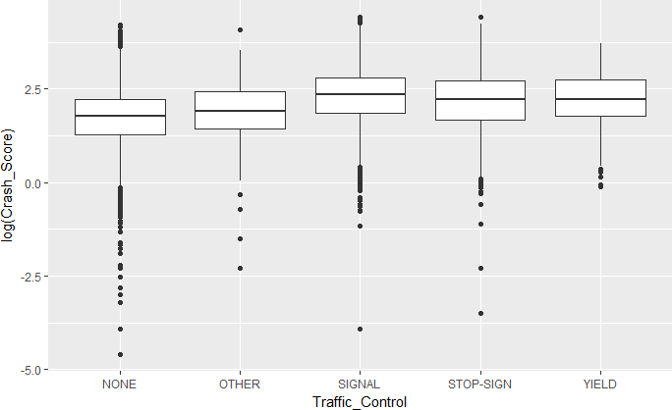

Looking at means and medians for the logarithms of crash scores reveals some other possible relationships beyond those already mentioned:

* Month: Higher in months October (10) through March (3)
* Rd_Class: Higher for US HWY
* Rd_Surface: Also, higher for the two ASPHALT levels relative to the two CONCRETE levels An example using Rd_Surface appears below.

|  |  |  |  |
| --- | --- | --- | --- |
| **Rd_Surface** | **mean** | **median** | **n** |
| <fctr> | <dbl> | <dbl> | <int> |
| SMOOTH ASPHALT | 1.946158 | 1.986504 | 20007 |
| COARSE ASPHALT | 1.913299 | 1.931521 | 1997 |
| CONCRETE | 1.688533 | 1.704746 | 692 |
| GROOVED CONCRETE | 1.708268 | 1.796747 | 371 |
| OTHER | 1.450069 | 1.611677 | 70 |

It appears there are several variables that may predict the target variable, but it should also be noted that none stand out as making large differences.

# Task 2 – Reduce the number of factor levels where appropriate (5 points)

The following combinations are made:

* Time_of_Day: Time 1 = OVERNIGHT, Times 2 and 6 = LATE‐EARLY, Times 3‐5 = DAYTIME. They have different means and medians and make sense with regard to accident severity.
* Rd_Feature: Combine INTERSECTION and RAMP into one level, INTERSECTION‐RAMP, and combine the others into OTHER. Intersection and ramp accidents are more likely to involve multiple vehicles and hence more damage.
* Rd_Character: Based on differing mean scores, combine the three with OTHER into OTHER and combine the remaining levels as STRAIGHT or CURVED.
* Traffic_Control: Combine NONE and OTHER into OTHER and the others into CONTROLLED to reflect some sort of control.

The other predictor variables either show little difference between the factor levels or enough differences throughout so that no obvious groupings exist.

# Task 3 – Use observations from principal components analysis (PCA) to generate a new feature (9 points)

Running the PCA on these three variables shows that only 22% of variation is explained by the first principal component (PC) and 35% by the first two PCs. However, the loadings may highlight interesting relationships among these variables.

The largest loadings on the first PC are:

* Rd_ConditionsDRY: ‐0.51
* Rd_ConditionsWET: 0.50
* WeatherCLEAR: ‐0.46
* Weather RAIN: 0.43

Applying these weights creates a variable that is strongly positive for rain/wet conditions and strongly negative for dry/clear conditions. It makes sense to pair up each of these as they would typically appear together, e.g. rain leads to wet roads.

Based on these results, I created a new feature, WETorDRY, based on the Rd_Conditions and Weather variables, deleting these two but retaining the Light variable as is.

# Task 4 –Select an interaction (7 points)

*The best candidates began by explaining what they were looking for when searching for an interaction. They next proposed an interaction based on an understanding of traffic behavior. They then used a graph to either confirm or dispel their interaction. In some cases, it was then necessary to try a new pair of variables.*

*Candidates were not required to create the interaction variable at this task. However, points were lost if the selected interaction was not used in subsequent tasks.*

*While the plots presented here used the logarithm of Crash_Score, it was not necessary to do so to earn full credit.*

An interaction is indicated when changing the level of one variable alters how levels of the other variables affect the target.

A first thought is Rd_Character and Rd_Class. Changing Rd_Character from STRAIGHT to CURVE may have a different effect depending on the Rd_Class. U.S. highways may have gentler curves than state highways and hence a different effect. As seen below, there does seem to be an interaction. For the CURVE cases the crash score is higher for US HWY. While this is contrary to my intuition, the interaction appears to be worth considering.

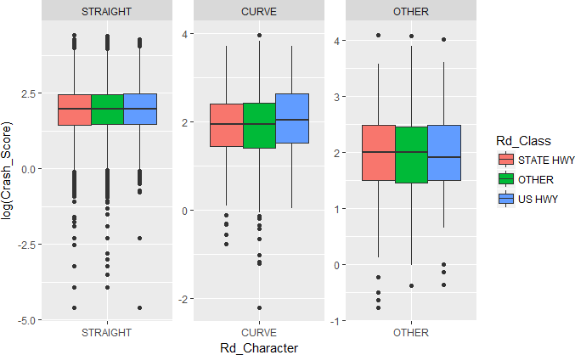

I’ll use this one for future work.

# Task 5 – Select a distribution and link function (10 points)

Before building a GLM, I split the data into training (75%) and testing (25%) sets. The average target value was 9.108 for the training set and 9.109 for the testing set, so the built‐in stratification of the target variable worked well.

I have retained Year as a numeric variable in case there is a trend effect that needs to be accounted for. I converted Month to a factor variable so that any seasonal effect can be determined.

Before investigating various GLMs, an OLS regression was run using the variables previously created but not the interaction from the previous task. Key values were an AIC of 113,388 and an RMSE of 6.2481 on the testing set. This provides a benchmark for further model development.

The only link function I will consider is the log link. This link ensures that all predictions are positive values, which is a characteristic of the target variable. The log link is also easy to interpret.

Because the target variable is highly right skewed, a skewed distribution such as the gamma seems appropriate. For the gamma distribution with the log link and the interaction term, the AIC is 102,336 and the RMSE is 6.2278. Both are improvements over the OLS model in that smaller values are preferred.

Another skewed distribution is the inverse Gaussian. Running it with the log link did not converge, so this combination could not be evaluated.

A Gaussian distribution with the log link, while not right skewed, will ensure positive predictions. For the normal distribution with the log link and the interaction term, the AIC is 113,208 and the RMSE is 6.2390.

Based on these numerical results (the gamma distribution has a lower AIC and essentially the same RMSE), the gamma distribution with the log link will be used from here on. Given that the two models have the same number of parameters, the lower AIC indicates that the loglikelihood is larger and thus the model fits better to the training data.

# Task 6 – Select features using AIC or BIC (12 points)

When a regression model is constructed using a large set of predictor variables there is a risk of overfitting. While additional variables can only improve the fit to the training data, they may actually decrease the fit against unseen (testing) data. One of the methods for handling this is the use of penalized likelihood, also known as information criteria. When fitting models by maximum likelihood, additional variables never decrease the loglikelihood value. An information criterion demands that for an additional variable to be included it must not just increase the loglikelihood, it must do so by at least a specific amount. Two popular criteria are the Akaike Information Criterion (AIC) and the Bayesian Information Criterion (BIC). For AIC, adding a variable requires an increase in the loglikelihood of two per parameter added. For BIC, the required per parameter increase is the logarithm of the number of observations. For the training dataset it is log(17,354) = 9.76 per parameter.

For this problem, BIC is a more conservative approach as there is a greater penalty for each parameter added, requiring more evidence to support additional variables. Our goal in this project is identify the key variables that relate to the target variable. As such, it makes sense to take a conservative approach and work with as few variables as necessary. Thus, BIC makes the most sense for this analysis.

Similarly, forward selection is more likely to end up with fewer variables. With forward selection, you start with no variables and then add variables until there is no improvement by the selected criterion. Backward selection starts with all the variables and sequentially removes them until no improvement results. It seems more likely that forward selection will result in a simpler model and hence that approach will be used.

When employing BIC and forward selection, the final model uses the following four features:

* Rd_Feature
* Rd_Configuration
* Time_of_Day
* Traffic_Control

When running the model with these four variables I noticed that Rd_Configuration = UNKNOWN was not significant compared to the base class. Forward selection with factor variables does not consider

individual factor levels, so this is a possible outcome of this method. Options available include combining this level with the base level or binarizing this variable and rerunning the analysis. Although this level is clearly not significant (p = 0.96), I’m not sure what to do with it as folding it into the base class may be hard to explain. There are only 57 records with this value, so leaving it in should not affect other conclusions.

# Task 7 – Validate the model (9 points)

Running the model with the four features identified in Task 6 produced an RMSE of 6.2301 on the test data. Training and testing the assistant’s OLS model on the same data produced an RMSE of 6.2481. The RMSE on unseen data for the GLM is slightly lower despite having far fewer features, suggesting that the GLM is the better model.

The following plot of residuals versus fitted values shows that the model performs well. Because all the predictors are factor variables there are only 2x5x3x2 = 60 possible predicted values, which explains the vertical array. All the vertical bars are centered near zero and spread symmetrically in each direction, indicating constant variance and near zero mean for residuals.

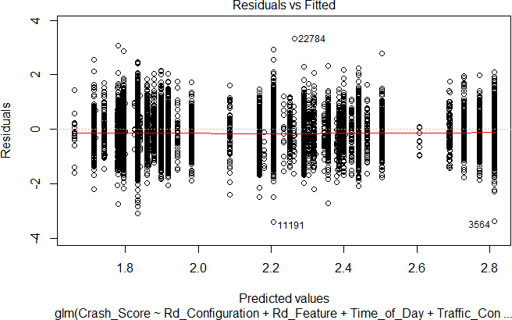

The q‐q plot shows that the normal distribution assumption (for the residuals) is maintained for most values, but not near the extremes. It appears a fatter‐tailed model may do better.

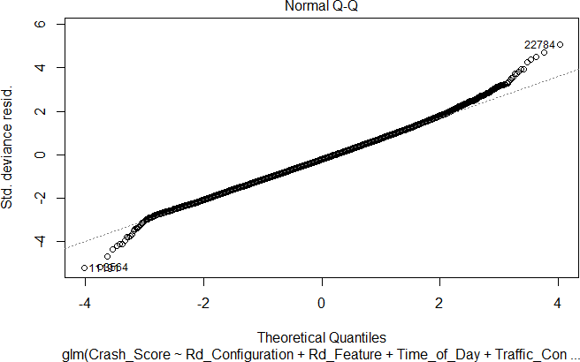

# Task 8 – Interpret the model (9 points)

The gamma model with a log link and four features was fit to the full dataset. The results are:

Coefficients:

|  |  |  |  |  |  |
| --- | --- | --- | --- | --- | --- |
|  | Estimate | Std. Error | t value | Pr(>|t|) |  |
| (Intercept) | 1.838598 | 0.006812 | 269.913 | < 2e-16 | *** |
| Rd_FeatureINTERSECTION-RAMP | 0.533185 | 0.012282 | 43.411 | < 2e-16 | *** |
| Rd_ConfigurationONE-WAY | -0.059694 | 0.017914 | -3.332 | 0.000863 | *** |
| Rd_ConfigurationTWO-WAY-PROTECTED-MEDIAN | 0.055913 | 0.014045 | 3.981 | 6.89e-05 | *** |
| Rd_ConfigurationTWO-WAY-UNPROTECTED-MEDIAN | 0.366560 | 0.010399 | 35.251 | < 2e-16 | *** |
| Rd_ConfigurationUNKNOWN | 0.016293 | 0.087165 | 0.187 | 0.851719 |  |
| Time_of_DayOVERNIGHT | -0.112799 | 0.023406 | -4.819 | 1.45e-06 | *** |
| Time_of_DayLATE-EARLY | -0.042275 | 0.011383 | -3.714 | 0.000205 | *** |
| Traffic_ControlCONTROLLED | 0.072497 | 0.011890 | 6.097 | 1.10e-09 | *** |

Due to the use of the log link, an appropriate way to interpret coefficients is to exponentiate them and subtract 1. The following table provides that interpretation:

|  |  |  |
| --- | --- | --- |
| Feature | Coefficient | Interpretation |
| Road Feature = INTERSECTION‐RAMP | 0.533 | 70% increase in Crash Score compared to non‐ intersection‐ramp. Crashes at intersections and ramps are likely to involve multiple cars, resulting in higher crash scores. |
| Rd_Configuration = ONE‐  WAY | ‐0.060 | 6% decrease in Crash Score compared to TWO‐WAY‐  NO‐MEDIAN. Less chance of a head‐on collision. |
| Rd_Configuration = TWO‐ WAY‐PROTECTED‐MEDIAN | 0.056 | 6% increase in Crash Score compared to TWO‐WAY‐NO‐ MEDIAN. This seems odd as protection should minimize head‐on collisions, but perhaps overall speeds are  higher. |
| Rd_Configuration = TWO‐ WAY‐UNPROTECTED‐ MEDIAN | 0.367 | 44% increase in Crash Score compared to TWO‐WAY‐ NO‐MEDIAN. This seems odd as a median should reduce head‐on collisions, but perhaps overall speeds are higher. |
| Rd_Configuration =  UNKNOWN | 0.016 | 2% increase in Crash Score compared to TWO‐WAY‐NO‐  MEDIAN. |
| Time of Day = OVERNIGHT | ‐0.113 | 11% decrease in Crash Score versus daytime (8am to 8pm). It is possible that drivers might be more cautious  at night and there are fewer cars on the road. |
| Time of Day = LATE‐EARLY | ‐0.042 | 4% decrease in Crash Score versus daytime (8am to 8pm). LATE‐EARLY includes times from 4AM to 8AM and 8PM to 12AM. During these times, there are likely fewer cars on the road compared to daytime, leading to lower crash scores. |
| Traffic Control = CONTROLLED | 0.072 | 7% increase in Crash Score versus no control. Traffic controls tend to be used in areas where there is a lot of traffic. Crashes in these areas are likely to involve  multiple vehicles. |

One would expect higher crash scores for crashes associated with multiple vehicles and higher speeds. The model output generally aligns with that intuition, however, the results for Rd_Configuration are not intuitive without more subject matter expertise.

# Task 9 – Investigate ridge and LASSO regressions (12 points)

There are a variety of methods to reduce overfitting. I previously used an information criterion, BIC, to reduce model complexity. An alternative to reducing the number of variables used is to reduce the coefficients of each variable. This is done by adding a penalty to the loglikelihood that relates to the size of the coefficients. This diminishes the effect, particularly for features that have limited predictive power. There are two approaches to doing this, which come under the general term regularization. (A third approach, a combination of the two, will not be discussed here.) In both cases there is a hyperparameter to estimate that controls the extent of the reduction. This is normally selected through cross‐validation. The specific methods explored are:

* Ridge regression: The penalty is proportional to the sum of the squares of the estimated coefficients. All of the coefficients are reduced but none are reduced to zero. Hence, all variables are retained.
* LASSO regression: The penalty is proportional to the sum of the absolute values of the estimated coefficients. All of the coefficients are reduced and some may be reduced to zero, effectively removing that variable.

Ridge regression is not recommended for this problem. Our goal is to identify variables that best predict Crash_Score and with all variables retained this approach will not be useful.

LASSO provides an alternative to forward and backward selection for variable selection. One advantage is that through cross‐validation it selects the best hyperparameter using the same criterion (RMSE) that will ultimately be used to judge the model against unseen data.

Regularization methods requires binarization of categorical variables, so unlike the stepAIC performed earlier, which treated all factor levels of one variable as a single object to remove or retain in the model, the LASSO removes individual factor levels if they are not significant with respect to the base level.

In running the two regressions, ridge produced an RMSE of 6.2516 and LASSO produced an RMSE of 6.2463. The LASSO removed 20 factor levels. Note that 10 of them were related to the Month variable.

Based on the above considerations and the fact that neither regularization approach improved the RMSE, I recommend that the original regression be used.

# Task 10 – Consider a decision tree (5 points)

A regression decision tree is an alternative method of linking predictors to a target variable. A tree divides the feature space into a finite, non‐overlapping set of buckets. All observations in a given bucket have the same predicted value. As with GLMs, there are methods to control overfitting such as cost‐ complexity pruning. The advantages of trees relative to GLMs are:

* They can be easier to interpret, provided there aren’t too many buckets. As the name implies, a tree‐like diagram can be constructed that indicates which observations get into the various buckets. Depending on the link function, the coefficients in a GLM may be difficult to explain and interpret.
* Categorical data is automatically handled. There is no need to binarize or determine a base class.

*The following additional advantages also received credit. This list is not exhaustive.*

* + *Interactions are automatically handled. There is no need to identify potential interactions prior to fitting the tree.*
  + *Variables are automatically selected. Some variables simply do not appear in the tree.*
  + *They can produce non‐linear relationships between the predictor variables and the response. (This is a weaker response because for this problem most all variables are categorical and hence linearity is not an issue.)*

Disadvantages relative to GLMs are:

* Even with pruning, there can be considerable overfitting to the training set.
* When underlying data changes, break points for decision trees can change significantly, leading to low user confidence in the model

*The following additional disadvantages also received credit. This list is not exhaustive.*

* + *When fitting a single tree, the locally greedy algorithm is unlikely to find a globally optimal tree.*
  + *With continuous predictors, the bucketing of features means that some small changes can lead to a large change in the prediction while other small changes can lead to no change in the prediction. (This is a weaker response because for this problem most all variables are categorical and hence are already bucketed.)*

# Task 11 – Executive summary (20 points)

# Our client, the North Carolina Department of Transportation (NCDT) would like to know which factors are important for road safety. By understanding what causes vehicle accidents, they can take measures to improve the safety of their roads, reduce their expenditure on maintenance hours in repairing dangerous roads, reduce the number of medical injuries from accidents, and improve the communities which these roads serve.

# Using predictive analytics, this analysis examines 23,127 vehicles crashes from 11 different variables. For each record, we have information regarding the type of vehicle, the type of road, the time of day, weather conditions, whether or not there was a stop sign, and other info. All of this is reliable because it was recorded from actual vehicle accidents from the years of 2014 – 2019.

# We want to improve vehicle safety by reducing both the number of accidents as well as the severity of each accident. We measure this by looking at the crash score, which is a composite index which takes both of these factors into account. This is a numeric value which ranges from 0 to 80, where a higher value indicates a more severe accident.

# As this graph shows, most accidents are not severe but few accidents are very severe.

# 

# We examined various graphical displays of the crash score. Based on this, we noticed that the crash score was higher at night, during midnight to 4 am, at intersections and on ramps, at two-way roads rather than on one-way roads, on dirt and less finished roads, during inclement weather such as snow or sleet or rain, during dark hours, when there are no traffic controls, and when in a work area. There was also a pattern over time, as scores were higher in October through March.

# All of this information is useful to know but is insufficient to say whether or not a road is safe or not. We need to understand how all of these factors relate to one another at once, which is what we do with predictive analytics.

# The raw data was too granular for our purposes. To fix this, we simplified the time of day to be either overnight, late early, or daytime instead of showing individual hours. We combined intersections and ramps. We said that all roads are either straight or curved. Traffic controls were said to be either controlled or not.

# We used an automatic machine learning method to look for patterns or groups within the traffic accidents. Perhaps there are certain clusters of accidents which show similar characteristics for weather and light and time of day, was the question that we were looking to answer. We used a method known as principal component analysis, which takes the information from many variables and collapses it down into simpler composite scores, known as principal components. We found that the simplest explanation came down to whether or not the road was dry or wet, if the weather was clear or not, or if there was rain. We used this info in our predictive models.

# We mentioned that each of these variables can interact with one another. We tested how road character and road class impact the crash score in tandem. In other words, straight roads may increase the risk of accidents more on highways (where the speed limit is higher) than on non-highways (where the speeds are lower). We used graphical displays to confirm that this hypothesis holds. We then tested this statistically by including an interaction term in our models.

# The first type of model which we considered was a generalized linear model (GLM). This is a commonly used model because it is accurate but also simple. It considers multiple factors at once and can predict the crash score. Some of the advantages to GLMs are that they can be explained using arithmetic in a simple spreadsheet, they can be adjusted for various shapes of the data, they can handle interaction effects, and they are easy to understand. The disadvantages are that they can have lower performance than other types of models, can be sensitive to extreme outlying values, and rely on several statistical assumptions which can be difficult to validate.

# The second type of model that we considered was a regularized regression model. This is an alternate type of linear model which automatically removed variables which are not predictive. This is better than the previous method that we used to remove unneeded variables because it has fewer statistical assumptions. In the previous GLM, we needed to decide on things such as the forward or backward stepwise selection and the choice of using AIC or BIC. This model did not show significant improvements on the test that we ran, and so we recommend using the first GLM model.

# We also test non-linear, tree-based models. A single decision tree was used. This has the advantage of automatically performing variable selection and interaction effects, as well as being easy to explain. Additionally, trees are not sensitive to extreme outlying points or missing values and handle categorical data without needed a base class or reference level. Disadvantages are that the predictive power can be lower than using bagged or boosted tree, the model can be sensitive to the training data used and although the results are simple at first, they can change when new data is used. The predictions from a tree are not smooth, or continuous numbers, but can dramatically change after only small changes are made to the input data. Note that this is less relevant to our problem at hand because our variables are categorical instead of numeric.

# A decision tree works by asking a serious of yes/no questions for each accident. For example, it will ask “is this a road or a highway?”, and based on this answer, it will ask an additional question such as “is it day or night?”, and will continue to ask further questions so that all of the crashes get put into groups. Then for each group the model says that the predicted crash score is the average of the crashes from that group.

# We can be confident that our results are going to work well in real life. This is because have already tested our models on new, unseen data using a training and test split. We kept 25% of the data “blind” and only showed it to the models after we had build the algorithm. This is an industry standard approach for validating the results of predictive models.

# We were also mindful of the time in which the data was collected. Data changes over time. To help NCDT account for this phenomenon in the future, we included the year variable in the model as well as the month to account for any seasonal changes.

# Our results showed significant improvement over a baseline using the Akaike Information Criterion (AIC), which is a common statistical measure of performance, as well as the Root Mean Squared Error. No single statistical measure should be relied on. Instead, we used both the AIC and the RMSE so that we can be very confident that the result is accurate. The AIC has the advantage of adjusting for the shape of the data, but the disadvantage of not always generalizing well to new, unseen data. The RMSE was based on the “unseen”, new data, which helps us to be confident that this analysis will work in real life. We compared several types of GLM and chose the one which provided the best statistical results.

# Not all info in the data will be useful at predicting the crash scores, and so we used several methods for removing the variables which were not relevant. After running this algorithm, we found that the most predictive variables were

# The road feature

# The road configuration

# The time of day

# The traffic control

# In addition to comparing the results on the blind-holdout data, we also checked that the statistical requirements for using a GLM were met. We looked the residual plots and found no patterns, which is what we expect. We looked at the normal QQ plot and found that the assumptions around the model residual distribution were met as well.

# Using our model, we can measure the risk level of each road. Based on the road’s characteristics, we can estimate how severe this risk level is. The below table provides such an explanation.

|  |  |  |
| --- | --- | --- |
| **Type of Road** | I**mpact on Crash Score** | **Possible Causes for Accident** |
| Road Feature = INTERSECTION‐RAMP | 70% increase in Crash Score compared to non‐ intersection‐ramp. Crashes at intersections and ramps are likely to involve multiple cars, resulting in higher crash scores. | Entering and exiting the highway. Missing stop signs and running red lights. Turning incorrectly at intersections. Turn right when there is a “do not turn right on red sign”. |
| Rd_Configuration = ONE‐ WAY | 6% decrease in Crash Score compared to TWO‐WAY‐NO‐MEDIAN. Less chance of a head‐on collision. | Head-on collisions during two-way traffic. No median in middle of road leading to people driving on the wrong side of the road. Two-way roads having more traffic and congestion. |
| Rd_Configuration = TWO‐ WAY‐PROTECTED‐MEDIAN | 6% increase in Crash Score compared to TWO‐WAY‐NO‐ MEDIAN. This seems odd as protection should minimize head‐on collisions, but perhaps overall speeds are higher. | This seems counter-intuitive because we expect that adding a median would make the road safer. Perhaps drivers are more nervous when they feel “boxed in” or overall speeds are higher on these roads. |
| Rd_Configuration = UNKNOWN | 2% increase in Crash Score compared to TWO‐WAY‐NO‐MEDIAN. | Untracked roads may have potholes and other damages. Rural community roads where drivers do not obey speed limits. |
| Time of Day = OVERNIGHT | 11% decrease in Crash Score versus daytime (8am to 8pm). It is possible that drivers might be more cautiousat night and there are fewer cars on the road. | Low visibility. Drunk driving. Driver fatigue. Higher stress levels. However, these can be offset because drivers are more cautious and there are fewer cars on the road. |
| Time of Day = LATE‐EARLY | 4% decrease in Crash Score versus daytime (8am to 8pm). LATE‐EARLY includes times from 4AM to 8AM and 8PM to 12AM. During these times, there are likely fewer cars on the road compared to daytime, leading to lower crash scores. | Fewer cars on the road. Drivers are more alert because they are likely commuting and have just gotten sleep. Fewer cars on the road as opposed to daytime. |
| Traffic Control = CONTROLLED | 7% increase in Crash Score versus no control. Traffic controls tend to be used in areas where there is a lot of traffic. Crashes in these areas are likely to involve multiple vehicles. | Traffic controls tend to be used in high-risk areas. |

# In conclusion, we have shown that accidents are not random. There are clear patterns which our predictive models can interpret. This analysis will be useful to the NCDT in improving the quality and safety of their roads. We could further improve this report if we had access to additional data, such as police reports, speed violations, personal driver demographics (was this a teen or new driver or was this an older driver with years of experience?), and other factors. This report is only limited to NC and so the results could be different in other U.S. States.